Ex:No: 10
Date: 27/01/2023
Simple programming exercise using(REPEAT, WHILE )

Program1
Write a function to build a string repeatedly until the value of the variable becomes s greater than 5. Then, we display the final string using a SELECT statement.

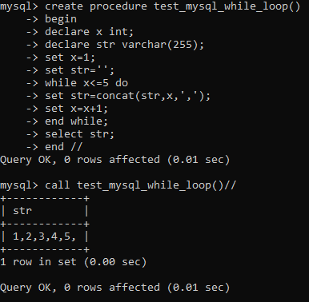

Program 2:

Write a function that uses REPEAT statement which would repeat the loop until income is greater than or equal to 4000, at which point the REPEAT loop would be terminated

